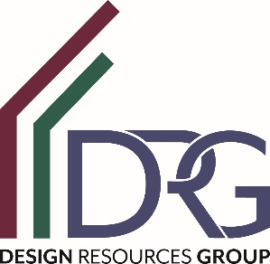

BIM Coordinator
We are seeking a full-time Building Information Modeling (BIM) Manager that will assist our design team with Revit to produce construction documents, renderings, and troubleshooting. This person should be solution oriented with exceptional Revit skills and have the ability to problem solve quickly and efficiently.
Responsibilities:
- Assist team members with technical support
- Produce construction documents independently and as part of a team
- Create marketing renderings
- Provide the design team with Revit training and resources.
- Uphold the Revit and CAD office standards.
Experience and Credentials:
- Drafting or architecture degree.
- 3+ years experience in an architecture office.
- Excellent technical, written and oral communications skills
- Strong attention to detail.
Benefits offered include health, dental, vision, life, flex spending, 401k with company match and paid time off.

